EXPERIMENT 12: - Create a Virtual Machine with 1 CPU, 2GB RAM and 15GB storage disk using a Type 2 Virtualization Software

Step 1: - Install VM Ware PlayStation

Step 2: - Create new virtual machine

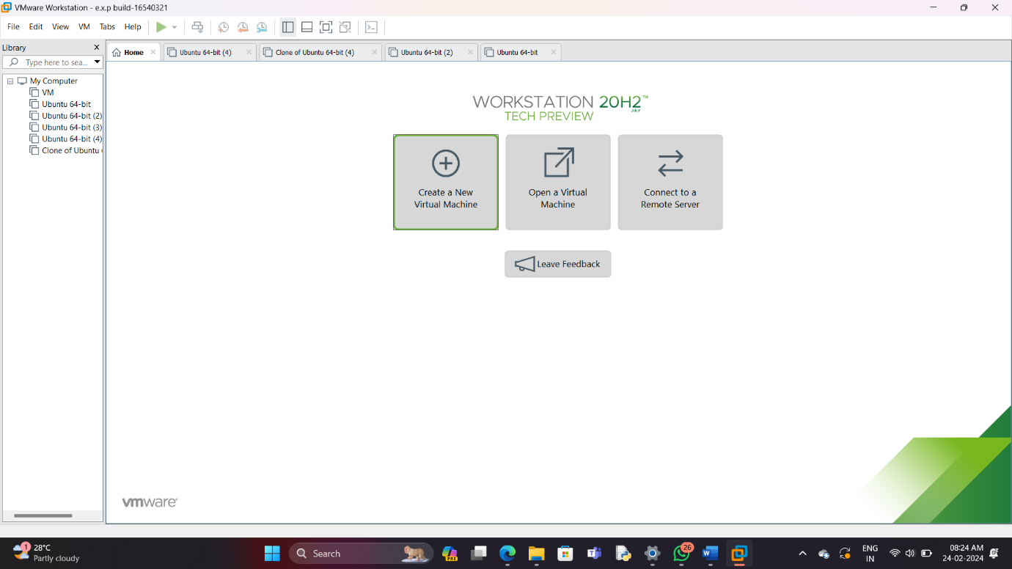

Step 3: - Choose Typical option and click Next

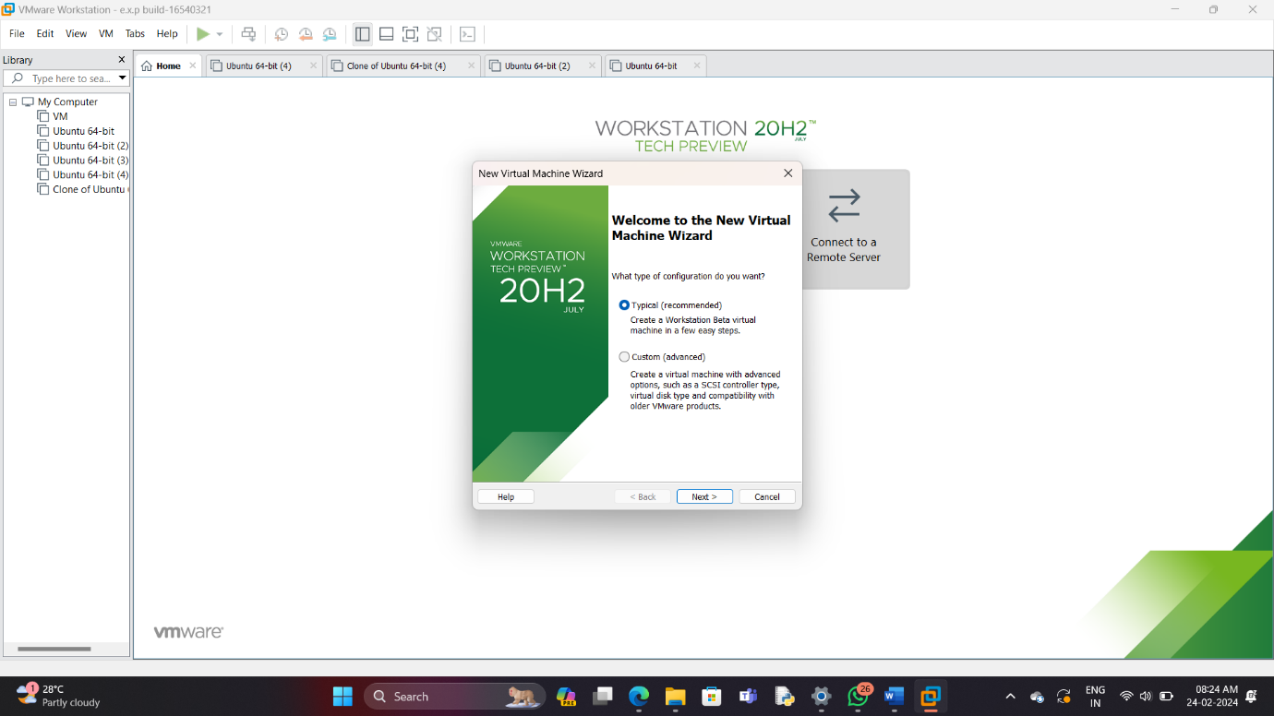

Step 4: - Click on the third option at guest os screen

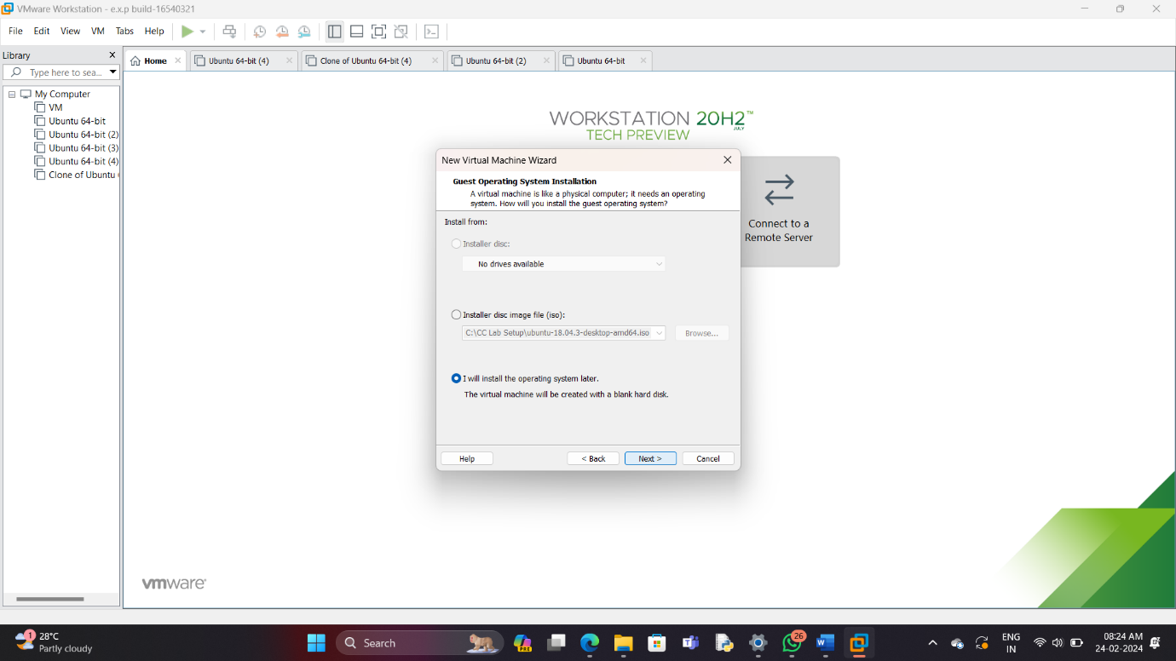

Step 5: - Choose the required os and click next

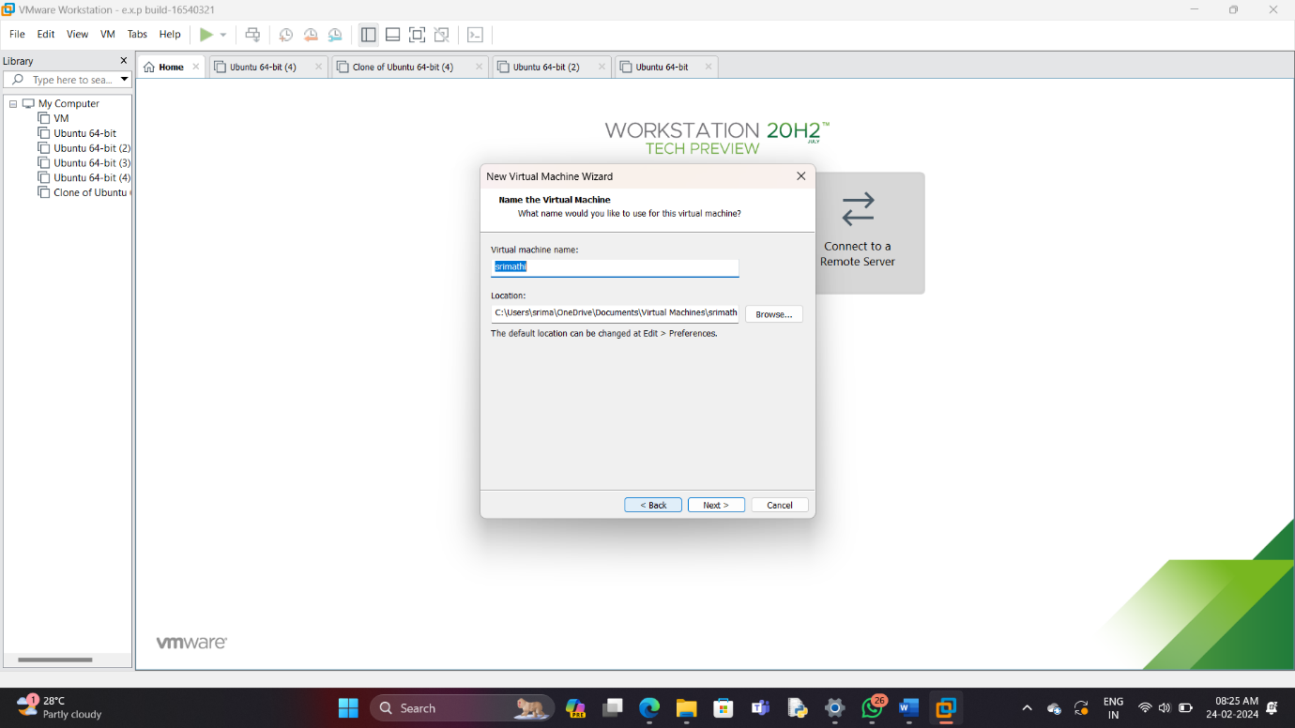

Step 6: - Enter the name of the virtual machine



Step 7: - Edit the disk space and click next

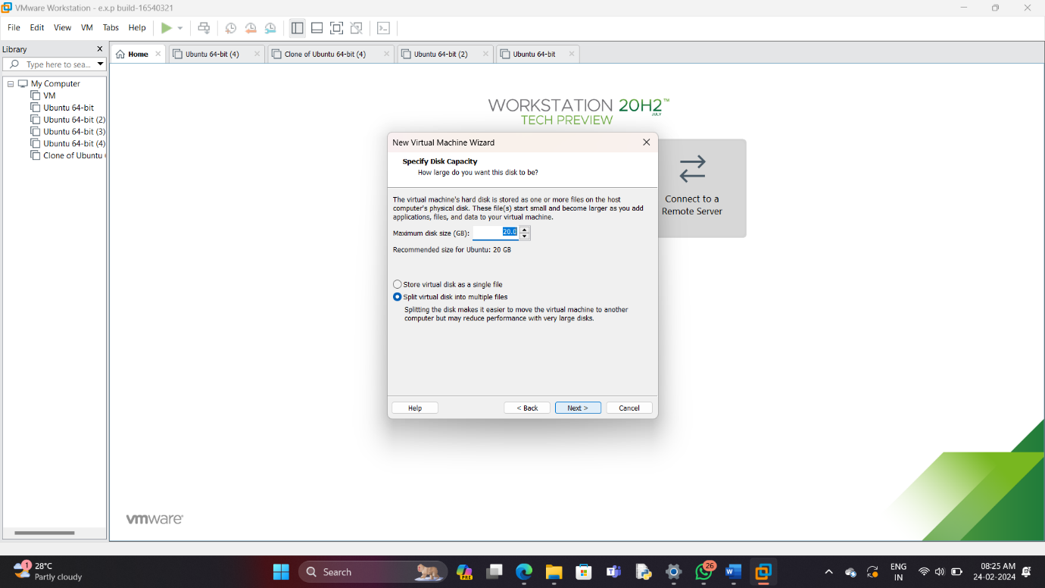

Step 8: - Check the summary, edit to your requirements and click next



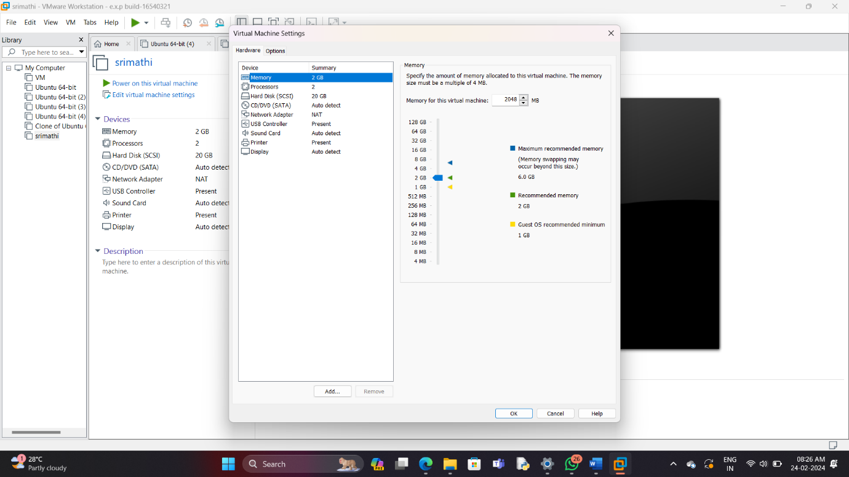

Step 9: - Edit the specifications

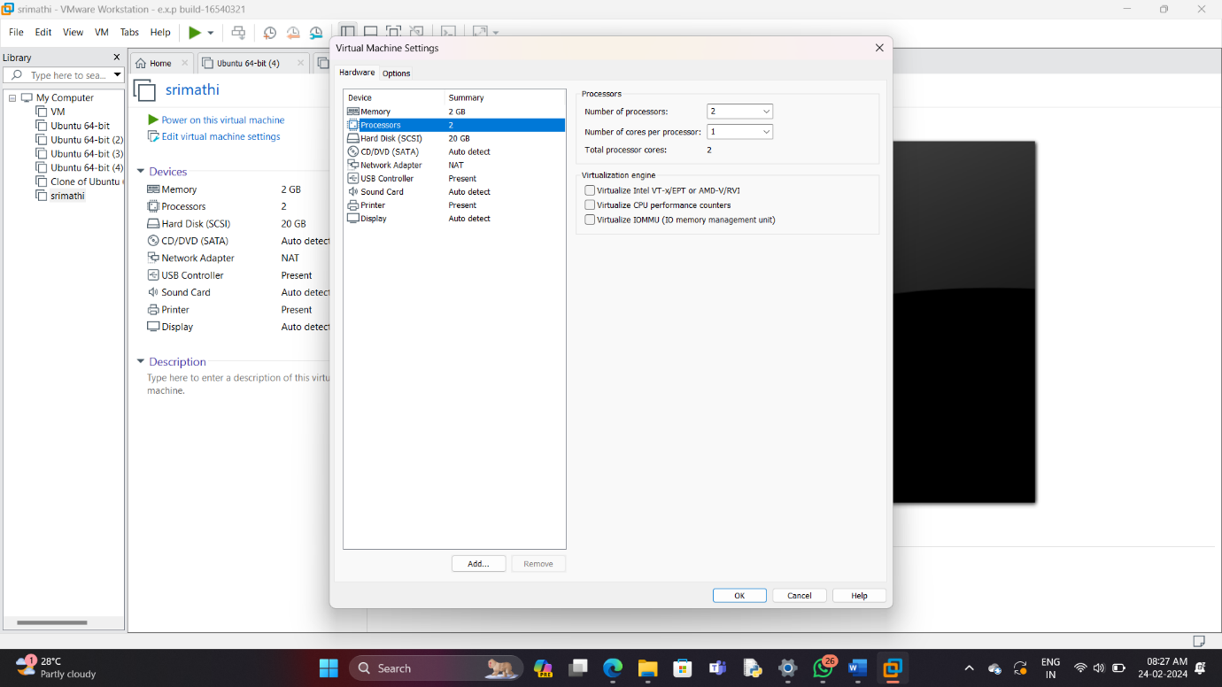

Step 10: - The experiment was completed successfully

